**EXPERIMENT NO.: 1**

**AIM: Installation of Java on Unix/Linux Machine (Without VirtualBox)**

■ This guide uses WSL (Windows Subsystem for Linux) to simulate a Linux environment directly on Windows.

**Step 1:** Enable WSL

1. Open PowerShell as Administrator
2. Run the following command: wsl –install



1. Restart your computer when prompted.
2. After restart, choose Ubuntu or install it from the Microsoft Store.

**Step 2:** Open Ubuntu (WSL)

* Search for 'Ubuntu' in Start Menu and open it.
* It will initialize and ask for a username and password.

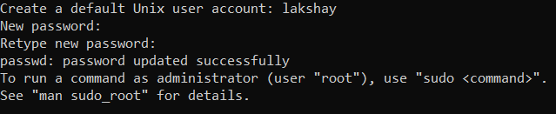

**Step 3:** Update the Package List Run the following command: sudo apt update

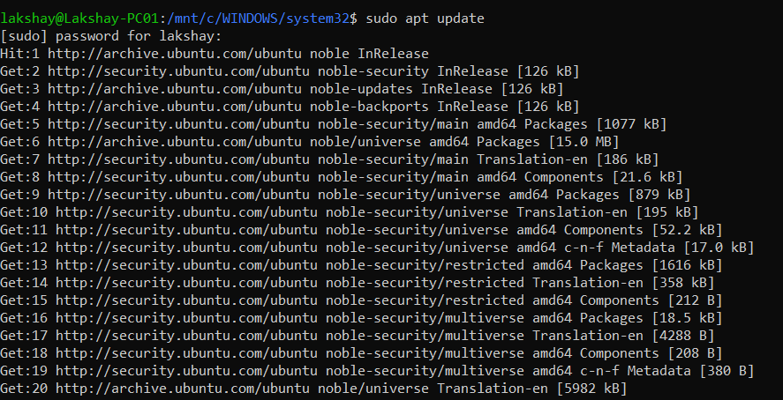

**Step 4:** Install Java (OpenJDK 8 or 11) - For Java 8:

sudo apt install openjdk-8-jdk -y - For Java 11: sudo apt install openjdk-11-jdk -y

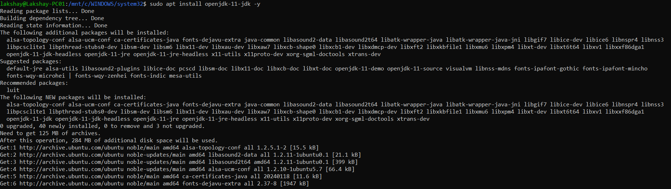

**Step 5:** Verify Java Installation Run: java -version

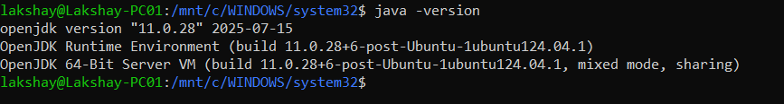

**Step 6:** Set JAVA_HOME Environment Variable (Optional)

1. Open .bashrc file: nano ~/.bashrc



1. Add the following lines at the end:

export JAVA_HOME=/usr/lib/jvm/java-8-openjdk-amd64 export PATH=$JAVA_HOME/bin:$PATH

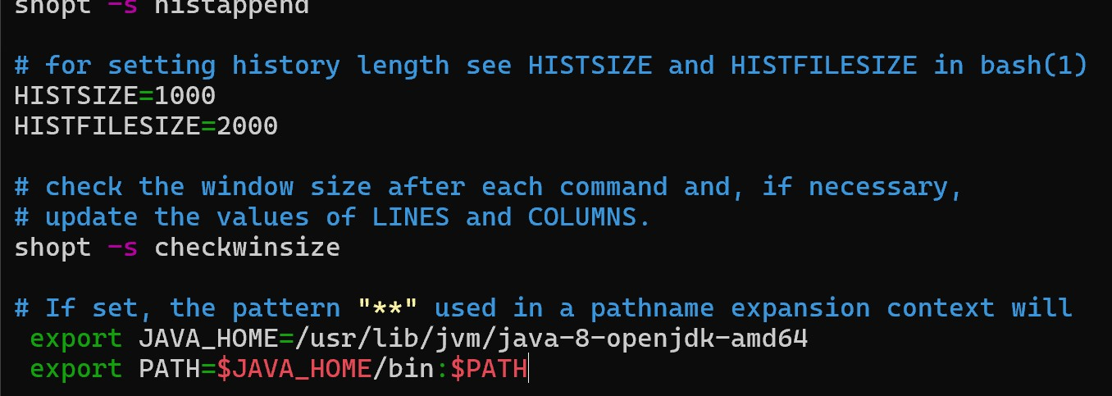

1. Save and exit (Ctrl+X, then Y, then Enter)
2. Reload bashrc: source ~/.bashrc
3. Verify JAVA_HOME is set: echo $JAVA_HOME



■ You now have Java installed on a Linux system simulated within Windows without using VirtualBox!